

Market potentials at alpla industrial
Questions & Answers

FehrAdvice & Partners AG
November 2025

Q&A – Market Potentials at ALPLA Industrial
1. Why is the sales organization changing at all?
In recent years, ALPLA Industrial has grown significantly – with dedicated teams in multiple countries and strong customer relationships.
At the same time, it has become clear that:
- We often work side by side rather than together.
- Knowledge remains local, and market potential goes untapped.
- Customers don’t always experience us as one unified partner.
This transformation creates the structure to better connect our efforts – for faster coordination, stronger impact, and one clear voice to the market.

2. What will stay the same – and what will change?
What stays | What changes
Customer closeness, pragmatism, drive | Centrally led sales organization (“Sales Hub”)
Local responsibility | New role and segment logic – less site-driven, more customer-focused
Personal relationships | More transparency, clear processes, structured feedback and coordination
The change is not about replacing people, it’s about how we collaborate, across plants and countries, with shared clarity and purpose.

3. What does this mean for my role in Sales or Customer Service?
The new structure will bring more clarity and orientation:
- Who owns which customer relationship?
- What are the rules for pricing, offers, and escalation?
- How do we share insights and feedback quickly?
For many of you, daily work will become more streamlined and transparent.
There are also new opportunities, especially for those in Customer Service Lead roles, Sales Managers, or Key Account Management (KAM).

4. Is the new structure already fixed?
Yes – the future model is confirmed:
- A centrally led, segment-driven sales structure with local anchoring.
- Governance principles will be introduced starting Q1 2026.
However: The details of implementation are still open, your input, feedback and experience matter. This is a shared path forward.

5. What happens next?
- December: Personal conversations on-site with Roland & Thomas
- January: One-on-one meetings with key stakeholders
- End of January: Team-wide Townhall to present the roadmap and participation formats
- After that: Step-by-step implementation with continuous dialogue and feedback

6. What about current responsibilities (e.g. Plant Managers)?
Plant managers do not lose relevance, they gain more focus on their operational core responsibilities.
Sales coordination and customer communication will be streamlined centrally, allowing local operations to run more efficiently and reliably.

7. Who can I reach out to if I have questions?
Feel free to contact Roland Baumann or Thomas Maibohm at any time. Your site meetings are also designed to address any open questions you may have.


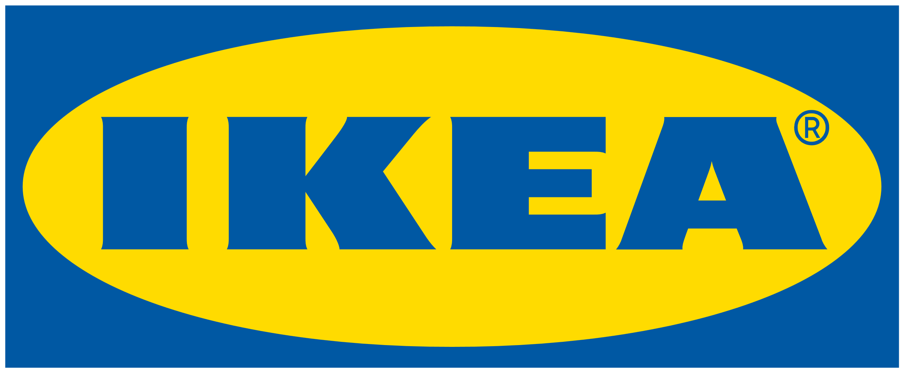



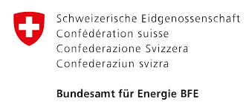

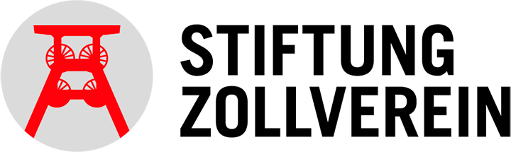


Über 6000+ experimente
400+ erfolgreiche Projekte für unsere Kunden
18 Branchen vertrauen unserer Expertise
Zu unseren Kunden zählen:

